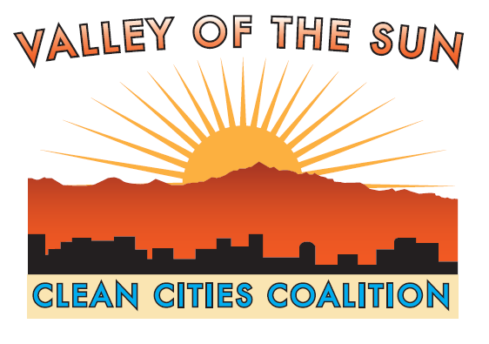
Please print form, fill out and mail with payment to:
Valley of the Sun Clean Cities Coalition, Inc.
1475 N. Scottsdale Rd.
Scottsdale, AZ 85275

Your Organization’s Name: __________________________________________________________________
Address: ________________________________________________________________________________
City: _______________________________ State: _____________________ Zip Code: ________________
Contact: _________________________________________ Telephone: _____________________________

E-mail: __________________________________________________________________________________
Membership Levels | Platinum * | Gold **
Corporate | $2,000/year | $1,000/year
Utility | $1,000/year | $500/year
City >500,000 population | $1,000/year | $500/year
City <500,000 population | $500/year | $250/year
County and State Agency | $500/year | $250/year
School District | $250/year | $125/year
Non-Profit | $250/year | $125/year
Individual |  | $100/year

* Platinum – Web logo placement, priority access & special opportunities with our stakeholders
** Gold – VSCCC Newsletter Recognition special opportunities with our stakeholders

Membership Level

Check enclosed for $

BECOME A MEMBER OF VSCCC

Help us work towards a cleaner Arizona by becoming a member of Valley of the Sun Clean Cities Coalition (VSCCC)!
VSCCC members are an important part of our team, and we value the knowledge, ideas and expertise that they bring to the coalition.

MEMBERSHIP BENEFITS

- PROMOTIONAL AND NETWORKING OPPORTUNITIES

- Members receive recognition on our coalition website, newsletters, articles, presentations and events.
- Gain access to hundreds of our local and national contacts including stakeholders, fleet managers, OEM, fuel providers, civic and government leaders, as well as key industry partners.

- CLEAN FUEL TECHNOLOGY AND RESOURCES

- Members gain access to 3 key national laboratories and their team of experts: the National Renewable Energy Labs in Colorado, Oakridge National Labs in Tennessee, and Argonne National Labs in Chicago.

- Receive the Clean Cities directory of all OEM Alternative Fuel Vehicles – light, medium, and heavy duty. We can provide specifications and comparisons in operating costs and emissions for these vehicles. You can also request a personalized profile of the equipment that you may be considering.

- Gain access to a web-based alternative fuel station locator that defines the location of stations supplying CNG, Biodiesel, Electric Charging, Ethanol, and Propane. This mapping service allows you to plot stations along the route of a local or interstate travel plan to reduce costs.

- Members have access to ASU Sky Song’s meeting rooms and facilities.

- PLAY A ROLE IN THE COALITION- PLATINUM MEMBERS ONLY

- Actively participate in coalition discussions and planning activities.

MEMBERSHIP LEVELS

PLATINUM MEMBERSHIP

- Platinum membership benefits include:

  - Promotional and Networking Opportunities including logo placement on the coalition website, priority recognition in our newsletters, articles, presentations and events as well as access to special opportunities with our stakeholders. Platinum members also gain priority access to hundreds of our local and national contacts including stakeholders, fleet managers, OEM, fuel providers, civic and government leaders, as well as key industry partners.

  - Access to Clean Fuel Technology and Resources including the 3 National Energy Laboratories, the Clean Cities directory of all OEM Alternative Fuel Vehicles – light, medium, and heavy duty, an online alternative fuel station locator and mapping tools, and meeting rooms and facilities at ASU Sky Song Complex.

  - Play a Role in the Coalition by taking part in coalition discussions and planning activities.

GOLD MEMBERSHIP

- Gold membership benefits include:

  - Promotional and Networking Opportunities such as recognition on our coalition website, newsletters, articles, presentations and events. Gold member also gain access to hundreds of our local and national contacts including stakeholders, fleet managers, OEM, fuel providers, civic and government leaders, as well as key industry partners.

  - Access to Clean Fuel Technology and Resources including the 3 National Energy Laboratories, the Clean Cities directory of all OEM Alternative Fuel Vehicles – light, medium, and heavy duty, an online alternative fuel station locator and mapping tools, and meeting rooms and facilities at ASU Sky Song Complex.
Membership Levels | Platinum * | Gold **
Corporate | $2,000/year | $1,000/year
Utility | $1,000/year | $500/year
City >500,000 population | $1,000/year | $500/year
City <500,000 population | $500/year | $250/year
County and State Agency | $500/year | $250/year
School District | $250/year | $125/year
Non-Profit | $250/year | $125/year
Individual |  | $100/year

Membership dues will be collected annually. Dues will be prorated on a quarterly basis beginning October 1st of each year. The VSCCC will consider alternative dues payment arrangements and in-kind organizational support.

